**AUTOMATED** **TICKETING** **AND** **BUS** **TRACKING** **SYSTEM**

**USING** **RFID**

**Abstract-** **The** **present** **ticketing** **system** **in** **public** **transport** **is** **tedious** **and** **has** **many** **drawbacks** **,** **such** **as**

**malfunction,** **malicious** **arguments** **among** **public** **,corruption** **and** **also** **many** **people** **travel** **without**

**paying** **.All** **these** **lead** **to** **unnecessary** **wastage** **of** **time** **and** **resources** **.Hence** **considering** **these**

**drawbacks,** **in** **this** **paper** **a** **much** **more** **efficient** **and** **user** **friendly** **,automated** **ticketing** **system** **along**

**with** **bus** **tracking** **system** **by** **using** **RFID** **is** **proposed** **.The** **system** **is** **designed** **to** **be** **cost** **effective**

**deployable** **on** **short** **term** **but** **open** **for** **easy** **extension.**

**INTRODUCTION**

**Radio-frequency** **indentification** **(RFID)** **is** **the** **use** **of** **a** **wireless** **non** **contact** **system** **that** **uses** **radio**

**frequency** **electromagnetic** **fields** **to** **transfer** **data** **from** **a** **tag** **attached** **to** **an** **object,** **for** **the** **purpose** **of**

**automatic** **indentification** **and** **tracking** **.**

**The** **present** **paper** **based** **ticketing** **system** **has** **its** **cons** **and** **also** **no** **prior** **notification** **of** **arrival** **and**

**departure** **of** **transports** **are** **available** **creating** **a** **lot** **of** **confusion** **among** **passengers.** **The** **tracking** **and**

**ticketing** **system** **using** **RFID** **can** **be** **merged** **to** **solve** **the** **prevailing** **problems** **.RFID** **based** **tickets** **is**

**proposed** **as** **it** **is** **low** **cost** **,easy** **operation** **,portability,** **durability,** **reliability** **and** **very** **user** **friendly.**

**Public** **carrying** **RFID** **based** **electronic** **tickets** **will** **have** **access** **to** **any** **bus** **service** **of** **the** **city** **only** **on**

**scanning** **his** **card** **on** **the** **scanner** **attached** **to** **the** **bus** **.Also** **the** **display** **screens** **at** **every** **bus** **stop** **will**

**notify** **the** **passengers** **,** **the** **departure** **and** **arrival** **time** **of** **the** **buses** **in** **the** **route** **.This** **automated**

**system** **will** **save** **time** **,** **have** **a** **higher** **authoritative** **inspection** **and** **reduce** **chaos** **and** **confusion** **on** **the**

**road.**

**SYSTEM** **DESCRIPTION**

**The** **proposed** **system** **has** **two** **functions** **automated** **ticketing** **along** **with** **bus** **tracking** **system.** **Firstly**

**let** **us** **consider** **automated** **ticketing.** **Each** **passenger** **will** **be** **given** **a** **RFID** **tag** **unique** **to** **their** **indentity.**

**In** **the** **particular** **card** **personal** **details** **like** **name,** **address** **,phone** **number** **will** **be** **stored** **and** **also** **along**

**with** **this** **a** **account** **information** **is** **stored** **in** **the** **card** **.The** **card** **is** **rechargeable** **from** **certain** **electronic**

**booths** **placed** **at** **certain** **locations** **of** **the** **city** **.Each** **bus** **will** **have** **RFID** **scanners** **attached** **at** **the**

**entrance** **and** **exit** **doors** **the** **passengers** **are** **supposed** **to** **scan** **their** **RFID** **cards** **while** **boarding** **and**

**while** **exiting** **from** **the** **bus** **.As** **soon** **as** **the** **passenger** **scans** **his** **card** **while** **boarding** **his** **unique** **id**

**number** **is** **stored** **and** **location** **is** **noted** **in** **the** **database** **,say** **the** **passenger** **travels** **and** **now** **his**

**destination** **has** **come** **now** **the** **passenger** **has** **to** **scan** **his** **card** **to** **exit** **from** **the** **bus.** **Based** **on** **the**



**number** **of** **zones** **travelled** **by** **the** **passenger** **the** **fare** **is** **automatically** **deducted** **from** **his** **account** **and**

**new** **balance** **is** **stored** **in** **his** **card.** **The** **sample** **information** **stored** **in** **the** **database** **about** **the** **route**

**distance** **and** **fare** **system** **is** **shown** **in** **Table-1.** **At** **the** **initial** **boarding** **of** **the** **passenger** **when** **he** **scans**

**for** **the** **first** **time** **the** **amount** **in** **his** **account** **is** **checked** **in** **order** **for** **the** **passenger** **to** **travel** **in** **a** **given**

**route** **he** **should** **posses** **a** **fixed** **minimum** **amount** **below** **which** **he** **would** **not** **be** **eligible** **to** **travel.**

**A** B C E

R R R

2R R

-BUS Stop

D

***Figure-1*** **Distances** **between** **different** **bus** **stops** **in** **a** **bus** **route.**

-BUS route

**Start** **location** **End** **location** **Distance** **Ticket**

**fare(credit)**

**A** **B** **R** **2x**

**A** **C** **2R** **4x**

**A** **D** **3R** **6x**

**A** **E** **3R** **6x**

**B** **C** **R** **2x**

**C** **E** **R** **2x**

***Table-1*** **Sample** **data** **to** **calculate** **bus** **fare** **for** **a** **particular** **route*.***

**Bus** **tracking** **system** **–** **All** **the** **buses** **will** **have** **a** **RFID** **tag** **fitted** **on** **the** **outer** **side** **at** **the** **front** **end**

**and** **at** **the** **rear** **end** **of** **the** **bus** **there** **will** **be** **a** **RFID** **scanner.** **The** **RFID** **tag** **at** **the** **front** **is** **fixed** **so** **that** **it**



**is** **scanned** **by** **the** **RFID** **scanners** **placed** **at** **each** **bus** **stop.All** **the** **details** **of** **the** **bus** **and** **its** **route** **details**

**will** **be** **stored** **in** **the** **card** **.The** **RFID** **scanner** **at** **the** **rear** **end** **on** **the** **bus** **is** **fixed** **to** **scan** **the** **RFID** **tag**

**which** **will** **be** **placed** **at** **each** **bus** **stop** **containing** **details** **of** **the** **location** **and** **zone** **of** **the** **stop** **and**

**other** **route** **details** **.Hence** **this** **tag** **is** **detected** **when** **the** **bus** **departs** **from** **a** **particular** **bus** **stop.** **This**

**helps** **the** **bus** **system** **know** **its** **location** **in** **its** **route.** **Based** **on** **the** **location** **information** **acquired** **from**

**each** **bus** **stop** **the** **automated** **fare** **system** **is** **governed.**

**There** **will** **be** **a** **base** **station** **where** **all** **the** **database** **is** **monitored** **.There** **will** **be** **constant** **data**

**exchange** **between** **various** **bus** **stops** **to** **the** **base** **station** **and** **vice** **versa.** **Let** **us** **consider** **an** **example** **of**

**a** **bus** **travelling** **in** **a** **particular** **route** **when** **the** **bus** **departs** **from** **its** **1st** **stop** **RFID** **scanner** **at** **the** **bus**

**stop** **scans** **the** **tag** **gets** **the** **information** **about** **the** **bus** **.Now** **based** **on** **the** **departure** **time** **of** **the** **bus** **,**

**the** **status** **of** **this** **bus** **is** **updated** **in** **all** **other** **bus** **stops** **falling** **in** **this** **route** **and** **also** **is** **updated** **to** **the**

**base** **station** **using** **wireless** **communication.** **At** **each** **bus** **stop** **there** **will** **be** **display** **boards** **displaying**

**information** **about** **buses** **arriving** **or** **travelling** **in** **the** **route** **along** **with** **their** **time** **.All** **the** **details** **of** **the**

**bus** **arriving** **and** **departing** **in** **various** **stops** **along** **with** **their** **time** **is** **updated** **to** **the** **base** **station** **for**

**better** **monitoring** **of** **the** **system** **and** **can** **also** **be** **used** **to** **schedule** **buses** **accordingly.**

**And** **also** **using** **the** **information** **collecting** **in** **the** **base** **station** **an** **SMS** **service** **can** **also** **be** **governed**

**from** **which** **passengers** **can** **get** **to** **know** **the** **status** **of** **the** **bus** **in** **which** **they** **want** **to** **travel** **in.**

**BASE**

**STATION**

BUS STOP

***Figure-2*** ***Schematic*** ***representation*** ***of*** ***data*** ***transfer*** ***in*** ***the*** ***system.***

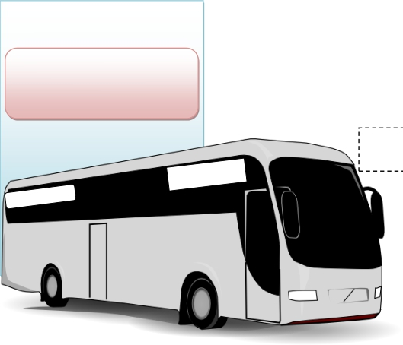

BUS STOP

DISPLAY SCREEN SHOWING DETAILS

OF ARRIVING AND DEPARTED BUSES

RFID TAG OF BUS

STOP CONTAINING

DETAILS OF STOP

RFID SCANNER TO KEEP

TRACK OF BUSES

LOCATION RFID TAG

RFID SCANNER

***Figure-2*** ***Diagram*** ***representing*** ***the*** ***setup*** ***of*** ***bus*** ***stop*** ***.***

**CONCLUSION-**

**The** **system** **is** **expected** **to** **be** **fully** **automated** **,** **reliable,** **transparent** **and** **convenient** **.The** **whole**

**system** **can** **also** **be** **used** **in** **vehicles** **on** **highways,** **their** **toll** **payment** **and** **in** **also** **in** **railway** **systems**

**with** **modifications** **accordingly.** **The** **card** **being** **reuseable** **,** **they** **are** **much** **more** **convenient** **compared**

**to** **present** **paper** **based** **ticketing** **system.** **The** **card** **can** **also** **be** **used** **as** **a** **universal** **travel** **pass** **card.Also**

**this** **system** **reduces** **traffic** **jam** **and** **chaos** **in** **the** **transport** **system** **.**

**COMPONENTS**

Components that the project needs are as follows

1. **Arduino** **Uno** **or** **MEGA**

Arduino is a single-board microcontroller, intended to make the application of interactive objects

or environments more accessible .The hardware consists of an open-source hardware board

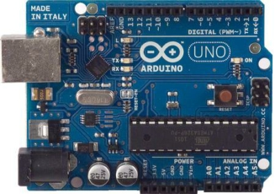

designed around an 8-bit Atmel AVR microcontroller, or a 32-bit Atmel ARM. Pre-programmed

into the on-board microcontroller chip is a boot loade that allows uploading programs into the

microcontroller memory without needing a chip (device) programmer .Arduino is chosen for the

following reasons and also simple and easy to interface with all kinds of sensors.

***Figure-4*** Picture of arduino uno.

**2.** RF SECTION

RF Transmitter Module – This will send data using RF communication which is received by

the receiver

RF Receiver Module- This will receive the data which is transferred from the transmitter

device. It also works similar to the transmitter module.

Encoder-The HT12E IC is a 4bit encoder which encodes the input data applied on it.

DECODER-The IC HT12D (18 pin) is a decoder that converts serial data into parallel which is

received by the RF Receiver module.

**3.**RFID Scanner

The **NSK125** **series** RFID Proximity OEM Reader Module has a built-in antenna in minimized

form factor. It is designed to work on the industry standard carrier frequency of 125 kHz.

This LF reader module with an internal or an external antenna facilitates communication with

Read-Only transponders—type UNIQUE or TK5530 via the air interface. The tag data is sent to

the host systems via the wired communication interface with a protocol selected from the

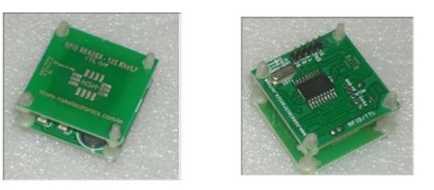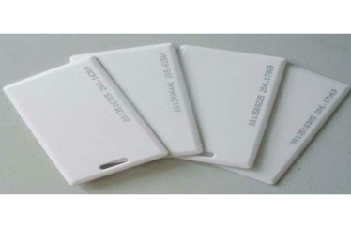

module Both RS232 and Wiegend Protocal

The LF module is best suited for applications in Access Control, Time and Attendance, Asset

Management, Handheld Readers, Immobilizers, and other RFID enabled applications.

**Features**

• Output- TTL or Wigand26

• Plug-and-Play, needs +5V to become a reader

• Buzzer indicates tag reading operation

• Compact size and cost-effective

**Figure-5** **Picture** **of** **RFID** **scanner**

**4.** **RFID** **TAGS**

**Figure-5** **Picture** **of** **RFID** **tags** **.**

COLLEGE

**5.OTHER** **Components** **–** **Other** **components** **which** **may** **be** **required** **for** **the**

**project** **accordingly** **.**

**References** **–** **Internet** **.**

**NAME** **-** ***CHANDAN*** ***KUMAR*** ***R***

GE-- ***P*** ***.E.*** ***S*** ***In*** ***stitute*** ***of*** ***Technology***

**SEMESTER**-- ***6*** ***TH*** ***SEM***